OPTIMIZATION TECHNIQUE USED FOR SOLAR DRYERS WITH THERMAL STORAGE USING TAGUCHI METHOD
SANJAY GAUTAM¹ & KRISHNA KANT KANAUJIA²
¹Assistant Professor, Department of Mechanical Engineering,
Maharaja Agrasen Himalayan Garhwal University Uttarakhand India

² Assistant Professor, Department of Mechanical Engineering, Maharaja Agrasen Himalayan Garhwal University Uttarakhand India

ABSTRACT
Solar energy is the largest renewable energy kind in the world. The current article contains the optimization approach used by the Taguchi method for solar dryers with thermal storage. Ginger (Zingiber officinalis, Roscoe, for example), has powerful anti-inflammatory properties including oleoresin. A lot of attention has been paid to Supercritical Fluid Extraction (SFE) since it is inert, cheap, readily accessible, Oduor less and tasteless, favorable to the environment. Various experimental studies to decrease time consumption have been carried out and increase solar dryer output. Solar dryers are optimized to improve their functioning precision and to reduce the drying time and cost. Several methods may be utilized to get optimal outcomes to optimize the entire setup. Taguchi optimization technique has been applied for the solar dryer experimental research in dry gingers in the current work. The findings revealed the optimum setup for dry ginger consisting of air speed, air flow and humidity.
Keywords: Optimization, Solar Dryers, Thermal, Ginger, Taguchi Method
INTRODUCTION
Drying and dehydrating is the most important everyday route where dehydration removes the moisture accessible on foodstuffs which enhance the lives of dry goods compared to fresh foodstuffs. Some changes take occur in the drying process both chemical and physical and complicated when the estimate relies on many Temperatures, humidity, and time variables, etc. The drying process requires strict content monitoring of moisture under direct sunlight. This component assesses the dehydration of foodstuffs.
Some agricultural goods have an extremely high humidity ratio and thus seem to be fresh and edible. In developing nations, adding, and reducing water with considerations of decaying variables is one of the few components that the loss of such goods should rely primarily on tropical and sub-tropical areas. These losses are primarily due to a lack of storage, harsh handling, transit, and many other causes. While it may be said that nations moving towards developing countries can lower agricultural and food-related losses and of improving the quality of the goods to be dried.
Energy storage not only contributes significantly to energy conservation but also improves energy system reliability and performance. Each system has a gap between energy supply and demand for energy. Energy storage may offset this mismatch and therefore save cash.
LITERATURE REVIEW
M. Moheno- Barruet et. al. (2021) The testing findings indicated that the drying rates were the greatest at 9 V with a drying rate of 1.5, 09 g/min and 0.55 g/min, and a drying range of 465 min and 1.46, 1.46 and 0.36 g /min for plantains at a drying rate of 495 min. Due to drying curves, the drying velocity in taro was found to be greater than in plantain. The database was used thereafter to develop the artificial neural network (ANN) architecture. produced during the trial stage of the solar dryer. The inputs for the model included six environmental variables and an operational variable, which supplied a drying velocity estimate for ANN (vd) producing R = 0.9822 between the experimental data and the data simulated via linear regression.
Johannes. P Angula and Freddie L. Inambao (2020) The technology to store the usage of materials deemed appropriate for the storage of thermal power is primarily dependent upon thermal power that may be released based on application for later use. It attempts to find the most appropriate and cost-effective materials that may be utilized for developing an optimum thermal power Storage device to store and release solar energy in hours of non-sunlight. The study has found two economically feasible concept ideas for the Design and construction of the system for thermal energy storage. Concept 1 is a rock bed system and Concept 2 is a thermal energy storage system with a hot tank.
Arshad Adeel (2019) With technological advances in nanotechnology, several thermal energy stock (TES) materials with potential thermal transportation characteristics were developed and improved. Solid-liquid phase change materials (PCMs), owing to their extremely favorable thermal characteristics, are widely utilized as TES materials for many energies uses. Potential applications, such as solar and Thermal, electrical, thermal, building, textile, foam, micro- and nano- PCM industry are thoroughly studied. Finally, this study emphasizes the potential future research pathways for thermal energy storage in micro-/nano-PCMs.
S. Krishnan and B. Sivaraman (2017) A solar dryer with 3 equally spaced trays that produce a maximum heat flow of 0.5 m2 (each of which provides a family) was built and its performance assessed. The dryer tests were carried out with and without thermal storage over three days during April, when the sunlight remained significant at 11.39° N Latitude and 79.69° E Longitude at Annamalai Nagar. The PCM was loaded in 20 aluminum tubes, 20 mm in diameter, with a length of 500 mm and 100 aluminum cans of 150 ml (excluding space for phase change). The findings were analyzed based on air velocity, temperature gradient and sun intensity for the change in thermal absorption and store.
Kumar Mahesh et. al (2016) Solar has attracted many leading academics across the globe to engage in the solar application area as an abundant, renewed, and sustainable energy source. In addition to numerous current drying process developments, which integrate various forms of auxiliary heating source with sunlight, a solar drying scheme does not only rely on solar power for its operation but is also undergoing recent fuel consumption trends. A study of different kinds of solar panels is included in this article including direct solar panels, indirect solar panels, Hybrid Solar Panels and its numerous drying uses.

DIFFERENT OPTIMIZATION TECHNIQUES USED IN SOLAR DRYING
The optimization methods are used to simulate the various sun drying processes and associated machinery to forecast the optimum value set. The most utilized optimization methods successfully applied to solar drying processes are ANN, GA, RSM and Taguchi.
- Application of ANN to Solar Drying Processes
Technological defects with biological systems. Different scientists have explored many neural network (NN) topologies for the modelling of the drying process. In terms of model correctness and simplicity, the choice of a suitable NN topology is essential. Dynamic modelling of the Agricultural drying characteristics by means of optimization techniques like the use of Artificial intelligence techniques have grown, including genetic algorithms and neural networks because neural network knowledge is suitable for determining the response of plants and fruit that are complicated procedures that cannot be used simply using math’s. Grain drying studies were performed to discover non-linear and system behavior using neural networking is challenging to explain.
Multiple linear regression (MLR) analysis and artificial neural networks were used to optimize a solar box drier (ANN). In the network and the predictive neural network model the conventional back-propagation study method demonstrated better forecasts than the regression drying efficiency model.
- Application of GA to Solar Drying Processes
The genetic algorithm is a worldwide search algorithm intended to mimic biological evolution principles in natural genetic systems. Different kinds of operators are employed in GA, although selection, recombination and mutation are frequently used. The GA replicates this process and determines ideal objectives. The genetic algorithm is one of the approaches of searching for the optimum value of the complicated objective function, based on crossover and mutation as in genetics. The intelligence artificial, neural neural network genetic algorithms Morimoto, Baerdemaeker & Hashimoto (1997a) have developed an optimal fruit store management technique. Morimoto, Purwanto, Suzuki, & Hashimoto (1997b) have been using genetic algorithms during fruit preservation to optimize heat treatment.
To estimate the next moisture content, and thus the drying rates, a feed-based neural network was utilized to estimate the moisture ratio by temperature, air speed, time period and moisture content. Later, the optimal input circumstances were found by utilizing a genetic algorithm. The findings indicated that the drying time was completely reduced using the optimal circumstances. Shahawar et al. used a rapid and exclusive non-dominated genetic sorting (NSGA-II) technique to detect optimal values of the PV/T system investigated to achieve better electrical and thermal efficiency.
- Application of RSM to Solar Drying Processes
RSM is a set of mathematical and statistical methods, helpful for modelling and analysis in situations where the interest response is affected by many factors and aims to maximize that response.
Response Surface Methodology (RSM) was used to improve soybean seed drying operation parameters. The research was done utilizing a three-level 4-factor factor fractional design to determine the optimal combination of initial humidity levels, drying air temperature, air velocity and loading depth, which may lead to high germination, Vigor and field development.
- Application of Taguchi method to Solar Drying Processes
Taguchi is a DOE instrument. Compared with DOE, this technique lowers the number of experiments. The Taguchi technique is primarily used to obtain optimum values and minimize the number of experimental studies efficiently. The researches in sun drying applications of the Taguchi technique are limited.
In addition, the Taguchi technique was used to find the optimal Extraction parameters for drying ginger to get high oil yields for ginger. The controls were reaction time, drying temperature, extraction pressure and particle size of ginger powder.
MATERIALS AND METHODS
In the current study experimental method has been carried out as a product in a solar dryer with drying gingers. The research was completed between 9 a.m. and 6 p.m. and the findings were recorded each hour. The dryer panels contained a total of 10 kg of ginger fresh. Each hour, measurements were detected in the chamber using measuring equipment for temperature, moisture, air flow etc. In the experiment the Taguchi Optimization technique was utilized to find the optimum configuration of the input parameters for an effective drying process.
Taguchi method
The Taguchi method is used mainly for producing high-quality SFEs and effectively reducing the number of experiments. The L9(34) orthogonal arrays were selected and there were 4 columns and 3 levels of 9 experimental runs (rows). The SN-to-noise ratio (SN-ratio, μl) was calculated using the loss function, which generated a repeated value translation function and was used as a variance measure for the experiment. The loss function depends on optimal quality standards and is used as an indicator of ideal conditions for a high S/N ratio value. The goal was to identify the best SFE parameters for improving the production of ginger oil in drying ginger. The production of ginger oil was considered to be more efficient in this respect. The loss function of the S/N ratio(ηij) is greater-than-better.:
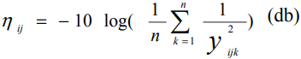 (2)
The optimum Process Parameter Level was established and the important variables for predicting an optimum performance of the S/N ratio (ηf) could be calculated based on chosen levels of the strong impact. The predicted S/N ratio (ηf) may be represented as:
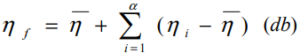 (3)
Where α is the average S/N ratio, α is the number of process parameters that have a substantial influence on the optimum conditions of the SFE process and α is the S/N ratio for the selection of optimal process parameters and its level.
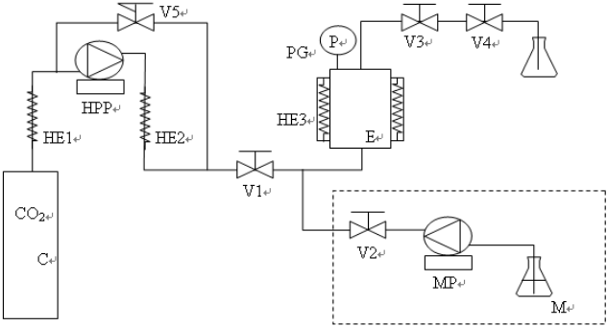
Figure 1: Scheme of supercritical carbon dioxide extraction equipment at batch-stirred apparatus for synthesis under high pressure

RESULT AND DISCUSSION

Table 1: Readings obtained in the experiment
Time | Ambient Temp.(0C) | Ambient Relative Humidity (%) | Upper Tray Temp.(0C) | Lower Tray Temp.(0C) | Exhaust Temp.(0C) | Exhaust Relative Humidity | Air Velocity (m/s) | Air Flow (m3/s) | Solar Radiation (W/m2)
9:00 am | 30.3 | 80.3 | 41.3 | 37.2 | 38.2 | 62.3 | 1.1 | 14.5 | 150.4
10:00 am | 31.4 | 79.5 | 43.7 | 37 | 38.5 | 60.6 | 2.12 | 28.9 | 161.2
11:00 am | 32.5 | 73.1 | 50.2 | 41.4 | 43.3 | 52.6 | 2.45 | 34.5 | 180.4
12:00 pm | 34.9 | 68.2 | 48.6 | 45.1 | 49.5 | 40.5 | 3.01 | 40.4 | 236.22
1:00 pm | 35.5 | 62.4 | 59 | 51.9 | 53 | 36.2 | 2.8 | 39.3 | 210.15
2:00 pm | 37.3 | 59.4 | 58.5 | 51.6 | 53.6 | 33.9 | 2.6 | 33.5 | 226.19
3:00 pm | 36.1 | 63.4 | 49.6 | 47.5 | 45.9 | 47.5 | 1.5 | 18.6 | 196.5
4:00 pm | 33.2 | 55.4 | 52.9 | 45.8 | 47.6 | 40.1 | 2.53 | 33.7 | 164.4
5:00 pm | 31.3 | 62.7 | 44 | 41.9 | 41.8 | 50.3 | 1.43 | 19.2 | 150.3
6:00 pm | 30.2 | 76 | 35.9 | 36.5 | 33.8 | 74.1 | 1.1 | 1.45 | 110.8
Mean | 33.0 | 68.04 | 48.37 | 43.59 | 44.5 | 49.8 | 2.06 | 26.4 | 178.6
RESULTS FOR TAGUCHI APPROACH
Moisture, airflow, air velocity and sun radiation measured optimization results. The very first phase signal was generated for the noise table. The criteria used was much bigger in this method. The findings were computed using the ANOVA method.

Table 2: S/N table for Optimization
S.N. | Ambient Relative Humidity | Air Velocity | Air Flow | Solar Radiation | S/N Ratio
1 | 73.1 | 2.45 | 34.5 | 180.4 | 45.12473
2 | 73.1 | 2.8 | 39.3 | 203.45 | 46.16915
3 | 73.1 | 1.5 | 18.6 | 184.56 | 45.32275
4 | 62.4 | 2.45 | 34.5 | 187.58 | 45.46373
5 | 62.4 | 2.8 | 39.3 | 210.15 | 46.45059
6 | 62.4 | 1.5 | 18.6 | 198.5 | 45.95521
7 | 63.4 | 2.45 | 34.5 | 195.3 | 45.81404
8 | 63.4 | 2.8 | 39.3 | 201.54 | 46.08723
9 | 63.4 | 1.5 | 18.6 | 196.5 | 45.86725
Response Table for Signal to Noise Ratios

Larger is better
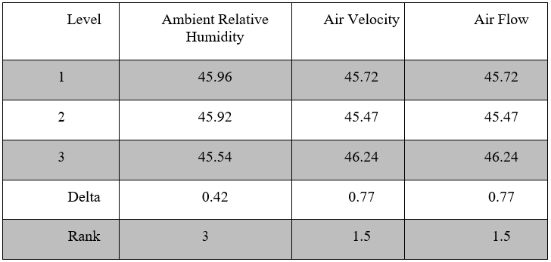
Table 3: Rank Table
ANALYSIS OF VARIANCE (ANOVA)

Table 4: Result from ANOVA
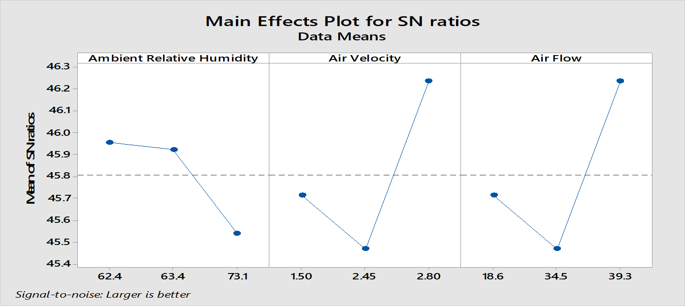
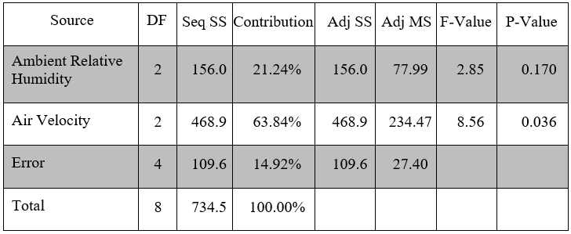

Fig 2: Response Graph for S/N Ratio
CONCLUSION
In this research, optimization techniques have been used for solar dryers with thermal storage. Studies on the use of response surface technique and Taguchi methods in sun drying systems are limited in the literature. Researchers may utilize these methods to simulate sun drying systems since they decrease the number of experimental tests. The experiment was conducted satisfactorily and hourly measurements were carried out. The results indicated that the maximum solar radiation intensity is about 236.72 W/m² at 12.00 pm. The measurements were further adjusted using the Taguchi L9 orthogonal array to achieve optimum solar dryer performance configuration. Air flow, air speed and humidity variables were dependent on the required S/N ratio.
REFERENCES
[1] Prakash, O., and Kumar, A., 2014, “Solar Greenhouse Drying: A Review,” Renew. Sust. Energy. Rev., 29, pp. 905–910.
[2] Sangamithra, A., Swamy, G. J., Prema, A. S., Priyavarshini, R., Chandrasekar, R., and Sasikala, S., 2014, “An Overview of a Polyhouse Dryer,” Renew. Sust. Energy. Rev., 40, pp. 902–910.
[3] Tomar, V, Tiwari, G. & Norton, B. (2017). Solar dryers for tropical food preservation: thermos physics of crops, systems, and components. Solar Energy, 154, pp.2-13. doi: 10.1016/j.solener.2017.05.066
[4] Prasad, J., Vijay, V.K., 2005. Experimental studies on drying of Zingiber officinale, Curcuma l. and Tinosopora cordifolia in solar-biomass hybrid drier. Renewable Energy 30, 2097-2109.
[5] Jairaj, K. S., Singh, S. P., and Srikant, K., 2009, “A Review of Solar Dryers Developed for Grape Drying,” Sol. Energy., 83, pp. 1698–1712.
[6] Johannes. P Angula and Freddie L. Inambao, “Optimization of Solar Dryers through Thermal Energy Storage: Two Concepts”, International Journal of Engineering Research and Technology. ISSN 0974-3154, Volume 13, Number 10 (2020), pp. 2803-2813
[7] M.; Martínez-Pereyra, G.; Cardoso-Fernández, V.; Rojas-Blanco, L.; Ramírez-Morales, E.; Pérez-Hernández, G.; Bassam, A. Experimental Evaluation and Theoretical Optimization of an Indirect Solar Dryer with Forced Ventilation under Tropical Climate by an Inverse Artificial Neural Network. Appl. Sci. 2021, 11, 7616. https:// doi.org/10.3390/app11167616
[8] S. Krishnan and B. Sivaraman, “Experimental Investigations on Thermal Storage in a Solar Dryer”, International Energy Journal 17 (2017) 23-36
[9] Kumar, M.; Sansaniwal, S.K.; Khatak, P. Progress in solar dryers for drying various commodities. Renew. Sustain. Energy Rev. 2016, 55, 346–360.
[10] Arshad, A.; Jabbal, M.; Yan, Y.; Darkwa, J. The micro-/nano-PCMs for thermal energy storage systems: A state of art review. Int. J. Energy Res. 2019, 43, 5572–5620.
[11] Bahrehmand, D.; Ameri, M.; Gholampour, M. Energy and exergy analysis of different solar air collector systems with forced convection. Renew. Energy 2015, 83, 1119–1130.
[12] Reyes, A., Mahn, A., & Vásquez, F. (2014). Mushrooms dehydration in a hybrid-solar dryer, using a phase change material. Energy Conversion and Management, 83, 241–248.
[13] Sarı, A., & Biçer, A. (2012). Thermal energy storage properties and thermal reliability of some fatty acid esters/building material composites as novel form-stable PCMs. Solar Energy Materials and Solar Cells, 101, 114–122.
[14] Dina, S. F., Ambarita, H., Napitupulu, F. H., & Kawai, H. (2015). Study on effectiveness of continuous solar dryer integrated with desiccant thermal storage for drying cocoa beans. Case Studies in Thermal Engineering, 5, 32–40.
[15] Bahramian, F.; Akbari, A.; Nabavi, M.; Esfandi, S.; Naeiji, E.; Issakhov, A. Design and tri-objective optimization of an energy plant integrated with near-zero energy building including energy storage: An application of dynamic simulation. Sustain. Energy Technol. Assess. 2021, 47, 101419.

